Assignment 5
2124UCSF1090

write a program using shell programming to implement an address book with options given below: a) create address book. b) view address book. c) insert a record. d) delete a record. e) modify a record. f) exit
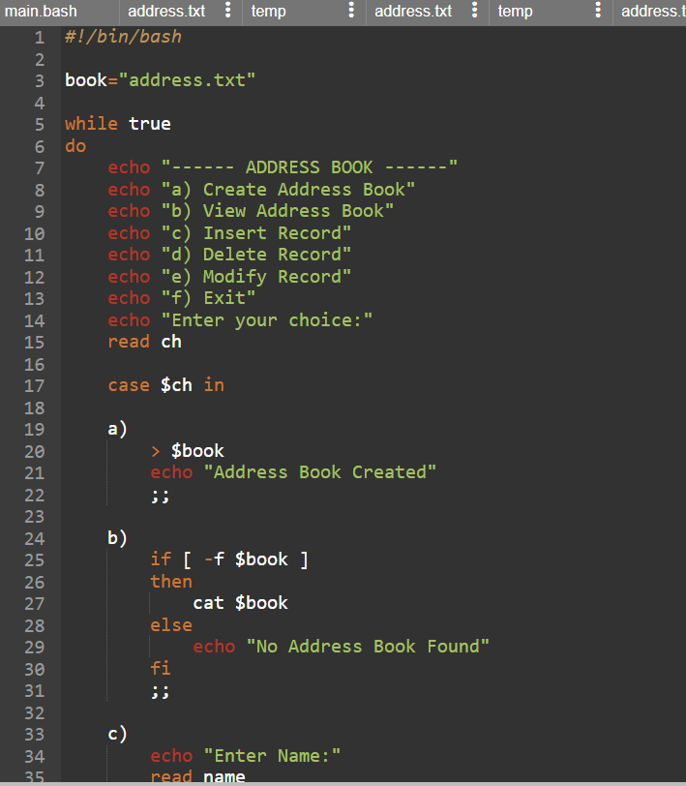

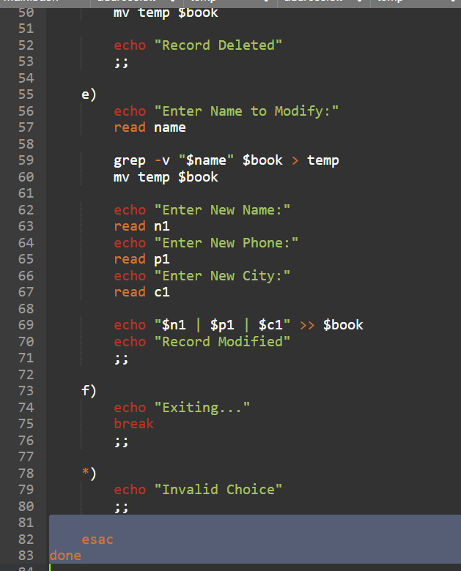

Output
